UNITED STATES

SECURITIES AND EXCHANGE COMMISSION
Washington, D.C. 20549

FORM SD

SPECIALIZED DISCLOSURE REPORT

TEXAS INSTRUMENTS INCORPORATED

(Exact Name of Registrant as Specified in Its Charter)

Delaware

001-03761

75-0289970

(State of incorporation)

(Commission File Number)

(I.R.S. Employer Identification No.)

12500 TI Boulevard, Dallas, Texas

75243

(Address of principal executive offices)

(Zip code)

Jeff McLaughlin, 214-479-3773

(Name and telephone, including area code, of the person to contact in connection with this report)

Check the appropriate box to indicate the rule pursuant to which this form is being filed, and provide the period to which the information in this form applies:

- Rule 13p-1 under the Securities Exchange Act (17 CFR 240.13p-1) for the reporting period from January 1 to December 31, 2019.

Section 1 — Conflict Minerals Disclosure

ITEM 1.01 Conflict Minerals Disclosure and Report

This Form SD should be read in conjunction with the definitions contained in the U.S. Securities and Exchange Commission (“SEC”) instructions to Form SD and related rules. “Conflict minerals” refers to four specific metals regardless of their country of origin or whether they are financing or benefiting armed conflict: tantalum, tin, tungsten and gold.

With respect to conflict minerals necessary to the functionality or production of products manufactured by Texas Instruments Incorporated (“TI”), or contracted by TI to be manufactured, and required to be reported on Form SD for 2019 (collectively, “CMs”), we exercised due diligence concerning the source and chain of custody of the CMs. For a description of our due diligence (which included a reasonable country of origin inquiry), please see our Conflict Minerals Report (Exhibit 1.01).

This Form SD is available on our web site at www.ti.com/conflictminerals. We are not incorporating by reference the contents of our web site into this Form SD.

ITEM 1.02 Exhibit

The registrant’s Conflict Minerals Report for 2019 is attached hereto as Exhibit 1.01.

Section 2 — Exhibits

ITEM 2.01 Exhibits

Exhibit 1.01 — Conflict Minerals Report as required by Items 1.01 and 1.02 of this Form.

2

SIGNATURES

Pursuant to the requirements of the Securities Exchange Act of 1934, the registrant has duly caused this report to be signed on its behalf by the duly authorized undersigned.

 | TEXAS INSTRUMENTS INCORPORATED
Date: June 1, 2020 | BY: /s/ Rafael R. Lizardi
 |  | Rafael R. Lizardi
 |  | Senior Vice President and Chief Financial Officer
 | 3

Exhibit 1.01

Conflict Minerals Report of Texas Instruments Incorporated

for the Year Ended December 31, 2019

This Conflict Minerals Report should be read in conjunction with the definitions contained in the U.S. Securities and Exchange Commission (“SEC”) instructions to Form SD and related rules. This Conflict Minerals Report and our conflict minerals policy are available on our web site at www.ti.com/conflictminerals. We are not incorporating by reference the contents of our web site into this Conflict Minerals Report. “Conflict minerals” refers to four specific metals regardless of their country of origin or whether they are financing or benefiting armed conflict: tantalum, tin, tungsten and gold.

- Design of Due Diligence

We have management systems and due diligence procedures (our “CM Process”) as a basis for supply-chain management and disclosure compliance relating to the conflict minerals necessary to the functionality or production of products manufactured by TI, or contracted by TI to be manufactured, and required to be reported for 2019 (collectively, “CMs”). We designed the CM Process with the intent to conform in all material respects with the Organization for Economic Co-Operation and Development (“OECD”) Due Diligence Guidance for Responsible Supply Chains of Minerals from Conflict-Affected and High-Risk Areas (Third Edition). The design of the CM Process included the following:

  - a conflict minerals policy;

  - an organizational structure and processes intended to ensure that our direct suppliers of materials that contain CMs and third-party manufacturers of our products that contain CMs (collectively, “Suppliers”) are made aware of TI’s policy on CMs and that information received by TI that is relevant to supply-chain due diligence reaches TI employees who have knowledge of the SEC disclosure requirements;

  - a process, which uses a reporting tool developed by the Responsible Minerals Initiative (“RMI”) and data gathered through the Responsible Minerals Assurance Process (“RMAP”) (as further described below), to achieve control and transparency over our CM supply chain and identify the risk that our products may contain CMs directly or indirectly financing or benefiting armed groups in the Democratic Republic of the Congo or any adjoining country (each a “Covered Country”);

  - assessment and management of risks identified through the process described above;

  - a mechanism for Suppliers and others to communicate to TI their concerns with respect to our CM Process;

  - reliance on the RMAP to validate supply chain due diligence; and

  - public reporting of the results of our due diligence.

II. Reliance on Third-Party Data

Our ability to determine the origin and chain of custody of CMs, and whether they directly or indirectly finance or benefit armed groups in any Covered Country (the “Conflict Status”), is limited. Our supply chain for CMs is complex. In many cases, we are multiple steps removed from the smelter or the mine, and we depend on information from Suppliers that themselves have incomplete information about the origin of the CMs incorporated in the products they supply to us.

To gain insight into the country of origin, chain of custody and Conflict Status of the CMs in our supply chain, we relied primarily on the findings of the RMAP. The RMAP is a voluntary program in which an independent third party evaluates smelters’ and refiners’ management systems and procurement practices and determines whether the smelter or refiner (“Smelter”) has demonstrated that all the materials it processed originated from conflict-free sources. The RMAP is overseen by the RMI, which was established by members of the Responsible Business Alliance (“RBA”) and the Global e-Sustainability Initiative. TI is a member of the RBA and RMI.

- Due Diligence Measures Taken

The measures we took to exercise due diligence on the source and chain of custody of our CMs are as follows:

- communicating our CM policy to Suppliers;

- directing Suppliers to provide information concerning Smelters in their supply chains by completing and sending to us the Conflict Minerals Reporting Template (a tool developed by the RMI that provides a common means for suppliers to provide their customers with information on the source of conflict minerals);

- analyzing Suppliers’ Conflict Minerals Reporting Template responses for completeness and internal consistency, and following up with Suppliers in an effort to obtain more information and ensure accuracy of information;

- comparing the information received from Suppliers with the data made available by the RMAP concerning the country of origin and Conflict Status of CMs processed or refined by Smelters; and

- reviewing other source materials for Smelters that are not compliant with the RMI (these Smelters may supply CMs to us for

1

products other than integrated circuits) if we were unable to determine, on the basis of the information provided by Suppliers and RMAP data, (i) the facility and country of origin of the CMs supplied to us, (ii) the Conflict Status of the CMs and (iii) whether the CMs were from recycled or scrap sources.

IV. Our Findings

We have determined that all of our integrated circuits (“ICs”) 1 were conflict-free. Our determination is based on the finding that all the Smelters identified to us by our Suppliers as being potentially in the supply chain for these products in 2019 supplied CMs exclusively from conflict-free sources. ICs accounted for approximately 92 percent of TI revenue in 2019.

In 2019, we continued to make progress in our due diligence efforts with regard to Smelters that are not compliant with the RMI (these Smelters may supply CMs to us for products other than ICs). While we primarily relied on information from our first-tier suppliers, in some cases we contacted second-tier suppliers for more complete information. That information, combined with the information available through the RMAP, provided us with greater insight into the Conflict Status of CMs identified as potentially in our supply chain.

Of the Smelters identified for 2019, we have determined that the CMs potentially supplied to us by 98 percent of the Smelters were conflict-free, as compared with 88 percent for 2018. Another 1 percent of the Smelters identified for 2019 have committed to participate in a third-party audit of their Conflict Status. In no instance did we find CMs in our supply chain to be from a source that, to our knowledge, was directly or indirectly financing or benefiting armed conflict in a Covered Country.

We do not have complete information about the CMs in our entire supply chain. For 2019, approximately 75 percent of Suppliers identified Smelters in their supply chains on a company-wide, division or product-line basis, without specifying which Smelters were relevant to products they supplied to TI. (Accordingly, we refer in this Conflict Minerals Report to Smelters as being “potentially” in our supply chain and as CMs “potentially” supplied to TI.) Industry efforts to collect and verify CM origin information remain incomplete. For Smelters that have committed to participate in a third-party audit of their Conflict Status, that status is currently undeterminable because the audits are not complete. The results of our due diligence, which are summarized in the charts below, reflect these limitations.

- “Integrated circuits” refers to finished semiconductor products that contain chips manufactured by or for TI and packaging subcomponents such as mold compounds, bond wires and lead frames. It excludes DLP® products, semiconductor modules and all other products manufactured by or for TI.

2

Smelter Status – Overview

IC Supply Chain
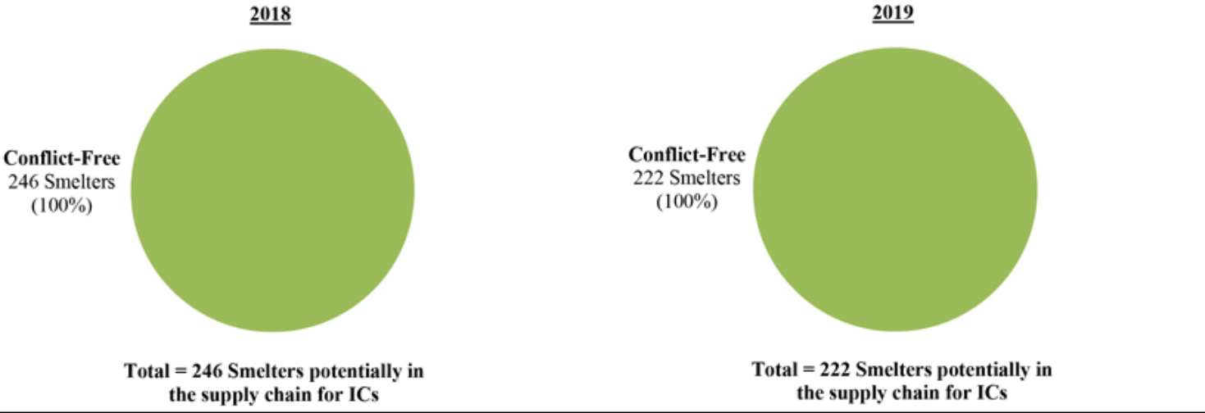

Overall Supply Chain

(including ICs)
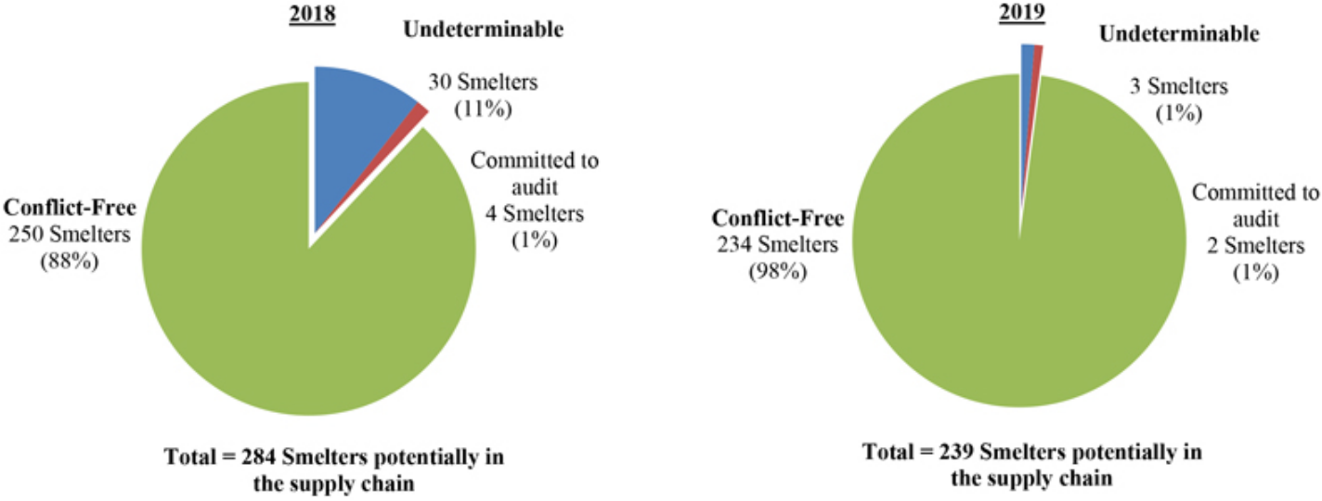

Smelters for which we determined, based on an independent third-party audit, the conflict minerals potentially supplied to TI were conflict-free

Smelters for which we determined the origin of the minerals potentially supplied to us was undeterminable - these Smelters have commited to participate in a third-party audit of their Conflict Status

Smelters for which we determined the origin of the minerals potentially supplied to us was undeterminable - these Smelters have not commited to participate in a third-party audit of their Conflict Status

3

Smelter Status – By CM

Tantalum Tin
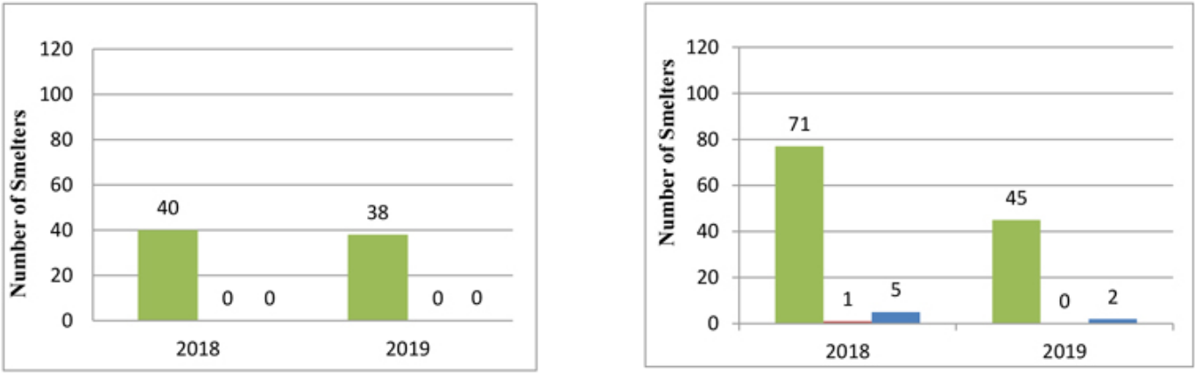

Tungsten Gold
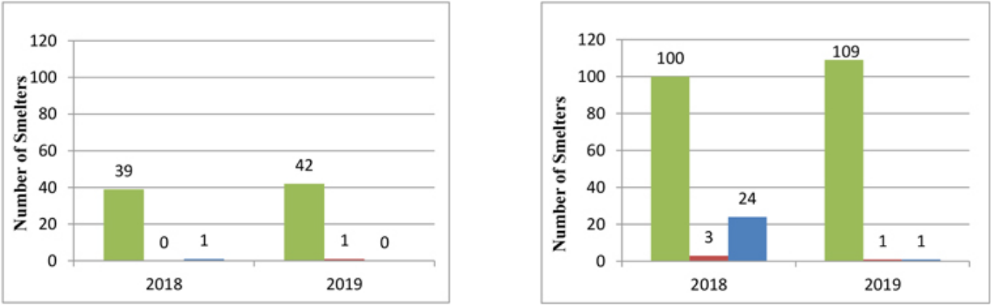

For an explanation of the color codes, see the notes in the Smelter Status – Overview charts directly above.

The Smelters identified by our Suppliers as potentially in our supply chain are listed in Appendix A hereto. Our efforts to determine the mine or location of origin of the CMs consisted of the due diligence measures described above.

- Product Scope

In 2019, our products were divided into two reportable segments as described in our annual report on Form 10-K for the year ended December 31, 2019: Analog (consisting of Power, Signal Chain, and High Volume product lines) and Embedded Processing (consisting of Connected Microcontrollers and Processors product lines). We report the results of our remaining business activities in Other. Other includes operating segments that do not meet the quantitative thresholds for individually reportable segments and cannot be aggregated with other operating segments (Other includes DLP products, calculators, and certain custom semiconductors known as application-specific integrated circuits). For further information about our products, please see the description of our products in Item 1 of the Form 10-K, which description is incorporated herein by reference.

4

VI. Risk-Mitigation Efforts

Since the period covered by this Conflict Minerals Report, we have taken, or will take, the following steps to mitigate the risk that our CMs directly or indirectly finance or benefit armed groups in the Covered Countries, including to improve our due diligence:

- redistribute copies of our CM policy to Suppliers;

- emphasize to Suppliers our expectation that they respond fully and promptly to our information requests;

- instruct Suppliers to advise us if they determine that any person or entity in their supply chain is directly or indirectly financing or benefiting armed groups in the Covered Countries;

- encourage Suppliers to direct all Smelters in their supply chains to participate in the RMAP or a similar third-party audit program; and

- contact various Smelters directly for information if their operating status changed, their RMI status changed, or they have refused to participate in a RMI audit.

VII. Independent Private Sector Audit

We obtained an independent private sector audit of this Conflict Minerals Report. The report by Crowe LLP is set forth as Appendix B to this Conflict Minerals Report.

[Intentionally blank]

5

Appendix A

Included in this Appendix A are Smelters that were identified to us by our Suppliers as potentially in our supply chain for 2019. As explained in this Conflict Minerals Report, the presence of a Smelter on the lists in this Appendix A does not mean that TI products necessarily contained CMs processed by that Smelter.

Table 1 | Total RMAP compliant Smelters: 234 | Tungsten Smelters | 42
 |  | Tin Smelters | 45
 |  | Tantalum Smelters | 38
 |  | Gold Smelters | 109
Table 2 | Total undeterminable Smelters: 5 | Tungsten Smelters | 1
 |  | Tin Smelters | 2
 |  | Tantalum Smelters | 0
 |  | Gold Smelters | 2

- Table 1:

Listed below are the 234 Smelters identified to us by our Suppliers as potentially in our supply chain for 2019 that the RMAP has reported as compliant with its audit protocols. On that basis, we have determined that the CMs supplied by these Smelters were conflict-free. The location information is as reported by the RMAP as of March 5, 2020.

*Smelters that potentially supply the CMs for our ICs.

 | Smelter | Metal | Country Location
1. | A.L.M.T. Corp.* | Tungsten | JAPAN
2. | ACL Metais Eireli* | Tungsten | BRAZIL
3. | Asia Tungsten Products Vietnam Ltd.* | Tungsten | VIETNAM
4. | Chenzhou Diamond Tungsten Products Co., Ltd.* | Tungsten | CHINA
5. | Chongyi Zhangyuan Tungsten Co., Ltd.* | Tungsten | CHINA
6. | Fujian Jinxin Tungsten Co., Ltd.* | Tungsten | CHINA
7. | Ganzhou Haichuang Tungsten Co., Ltd.* | Tungsten | CHINA
8. | Ganzhou Huaxing Tungsten Products Co., Ltd.* | Tungsten | CHINA
9. | Ganzhou Jiangwu Ferrotungsten Co., Ltd.* | Tungsten | CHINA
10. | Ganzhou Seadragon W & Mo Co., Ltd.* | Tungsten | CHINA
11. | Global Tungsten & Powders Corp.* | Tungsten | UNITED STATES
12. | Guangdong Xianglu Tungsten Co., Ltd.* | Tungsten | CHINA
13. | H.C. Starck Smelting GmbH & Co. KG* | Tungsten | GERMANY
14. | H.C. Starck Tungsten GmbH* | Tungsten | GERMANY
15. | Hunan Chenzhou Mining Co., Ltd.* | Tungsten | CHINA
16. | Hunan Chuangda Vanadium Tungsten Co., Ltd. Wuji* | Tungsten | CHINA
17. | Hunan Chunchang Nonferrous Metals Co., Ltd.* | Tungsten | CHINA
18. | Hunan Litian Tungsten Industry Co., Ltd. | Tungsten | CHINA
19. | Hydrometallurg, JSC* | Tungsten | RUSSIAN FEDERATION
20. | Japan New Metals Co., Ltd.* | Tungsten | JAPAN
21. | Jiangwu H.C. Starck Tungsten Products Co., Ltd.* | Tungsten | CHINA
22. | Jiangxi Gan Bei Tungsten Co., Ltd.* | Tungsten | CHINA
23. | Jiangxi Tonggu Non-ferrous Metallurgical & Chemical Co., Ltd.* | Tungsten | CHINA
24. | Jiangxi Xinsheng Tungsten Industry Co., Ltd.* | Tungsten | CHINA
25. | Jiangxi Yaosheng Tungsten Co., Ltd.* | Tungsten | CHINA
26. | Kennametal Fallon* | Tungsten | UNITED STATES
27. | Kennametal Huntsville* | Tungsten | UNITED STATES
 | 6

28. | KGETS Co., Ltd.* | Tungsten | KOREA (REPUBLIC OF)
29. | Lianyou Metals Co., Ltd. | Tungsten | TAIWAN
30. | Malipo Haiyu Tungsten Co., Ltd.* | Tungsten | CHINA
31. | Masan Tungsten Chemical LLC (MTC)* | Tungsten | VIETNAM
32. | Moliren Ltd.* | Tungsten | RUSSIAN FEDERATION
33. | Niagara Refining LLC* | Tungsten | UNITED STATES
34. | Philippine Chuangxin Industrial Co., Inc.* | Tungsten | PHILIPPINES
35. | Tejing (Vietnam) Tungsten Co., Ltd.* | Tungsten | VIETNAM
36. | Unecha Refractory metals plant* | Tungsten | RUSSIAN FEDERATION
37. | Wolfram Bergbau und Hütten AG* | Tungsten | AUSTRIA
38. | Woltech Korea Co., Ltd.* | Tungsten | KOREA (REPUBLIC OF)
39. | Xiamen Tungsten (H.C.) Co., Ltd.* | Tungsten | CHINA
40. | Xiamen Tungsten Co., Ltd.* | Tungsten | CHINA
41. | Xinfeng Huarui Tungsten & Molybdenum New Material Co., Ltd.* | Tungsten | CHINA
42. | Xinhai Rendan Shaoguan Tungsten Co., Ltd.* | Tungsten | CHINA
43. | Alpha* | Tin | UNITED STATES
44. | Chenzhou Yunxiang Mining and Metallurgy Co., Ltd.* | Tin | CHINA
45. | Chifeng Dajingzi Tin Industry Co., Ltd.* | Tin | CHINA
46. | China Tin Group Co., Ltd.* | Tin | CHINA
47. | Dowa* | Tin | JAPAN
48. | EM Vinto* | Tin | BOLIVIA
49. | Fenix Metals* | Tin | POLAND
50. | Gejiu Kai Meng Industry and Trade LLC* | Tin | CHINA
51. | Gejiu Non-Ferrous Metal Processing Co., Ltd.* | Tin | CHINA
52. | Gejiu Yunxin Nonferrous Electrolysis Co., Ltd. * | Tin | CHINA
53. | Gejiu Zili Mining and Metallurgy Co., Ltd.* | Tin | CHINA
54. | Guangdong Hanhe Non-Ferrous Metal Co., Ltd* | Tin | CHINA
55. | Guanyang Guida Nonferrous Metal Smelting Plant* | Tin | CHINA
56. | HuiChang Hill Tin Industry Co., Ltd.* | Tin | CHINA
57. | Huichang Jinshunda Tin Co., Ltd.* | Tin | CHINA
58. | Jiangxi New Nasan Technology Ltd.* | Tin | CHINA
59. | Ma’anshan Weitai Tin Co., Ltd. | Tin | CHINA
60. | Magnu’s Minerais Metais e Ligas Ltda.* | Tin | BRAZIL
61. | Malaysia Smelting Corporation (MSC)* | Tin | MALAYSIA
62. | Melt Metais e Ligas S.A.* | Tin | BRAZIL
63. | Metallic Resources, Inc.* | Tin | UNITED STATES
64. | Metallo Belgium N.V.* | Tin | BELGIUM
65. | Metallo Spain S.L.U.* | Tin | SPAIN
66. | Mineração Taboca S.A.* | Tin | BRAZIL
67. | Minsur* | Tin | PERU
68. | Mitsubishi Materials Corporation* | Tin | JAPAN
69. | O.M. Manufacturing Philippines, Inc.* | Tin | PHILIPPINES
70. | O.M. Manufacturing (Thailand) Co., Ltd.* | Tin | THAILAND
71. | Operaciones Metalurgical S.A.* | Tin | BOLIVIA
 | 7

72. | PT Artha Cipta Langgeng* |  | Tin | INDONESIA
73. | PT ATD Makmur Mandiri Jaya* |  | Tin | INDONESIA
74. | PT Mitra Stania Prima* |  | Tin | INDONESIA
75. | PT Refined Bangka Tin* |  | Tin | INDONESIA
76. | PT Timah Tbk Kundur* |  | Tin | INDONESIA
77. | PT Timah Tbk Mentok* |  | Tin | INDONESIA
78. | Resind Indústria e Comércio Ltda.* |  | Tin | BRAZIL
79. | Rui Da Hung* |  | Tin | TAIWAN
80. | Soft Metais Ltda.* |  | Tin | BRAZIL
81. | Thai Nguyen Mining and Metallurgy Co., Ltd* |  | Tin | VIETNAM
82. | Thaisarco* |  | Tin | THAILAND
83. | Tin Technology & Refining* |  | Tin | UNITED STATES
84. | White Solder Metalurgia e Mineração Ltda.* |  | Tin | BRAZIL
85. | Yunnan Chengfeng Non-ferrous Metals Co., Ltd. * |  | Tin | CHINA
86. | Yunnan Tin Company Limited* |  | Tin | CHINA
87. | Yunnan Yunfan Non-ferrous Metals Co., Ltd. |  | Tin | CHINA
88. | Asaka Riken Co., Ltd.* |  | Tantalum | JAPAN
89. | Changsha South Tantalum Niobium Co., Ltd.* |  | Tantalum | CHINA
90. | D Block Metals, LLC* |  | Tantalum | UNITED STATES
91. | Exotech Inc.* |  | Tantalum | UNITED STATES
92. | F&X Electro-Materials Ltd.* |  | Tantalum | CHINA
93. | FIR Metals & Resource Ltd. * |  | Tantalum | CHINA
94. | Global Advanced Metals Aizu* |  | Tantalum | JAPAN
95. | Global Advanced Metals Boyertown* |  | Tantalum | UNITED STATES
96. | Guangdong Zhiyuan New Material Co., Ltd.* |  | Tantalum | CHINA
97. | H.C. Starck Co., Ltd.* |  | Tantalum | THAILAND
98. | H.C. Starck Hermsdorf GmbH* |  | Tantalum | GERMANY
99. | H.C. Starck Inc.* |  | Tantalum | UNITED STATES
100. | H.C. Starck Ltd.* |  | Tantalum | JAPAN
101. | H.C. Starck Smelting GmbH & Co. KG* |  | Tantalum | GERMANY
102. | H.C. Starck Tantalum and Niobium GmbH* |  | Tantalum | GERMANY
103. | Hengyang King Xing Lifeng New Materials Co., Ltd.* |  | Tantalum | CHINA
104. | Jiangxi Dinghai Tantalum & Niobium Co., Ltd.* |  | Tantalum | CHINA
105. | Jiangxi Tuohong New Raw Material* |  | Tantalum | CHINA
106. | JiuJiang JinXin Nonferrous Metals Co., Ltd.* |  | Tantalum | CHINA
107. | Jiujiang Tanbre Co., Ltd. * |  | Tantalum | CHINA
108. | Jiujiang Zhongao Tantalum & Niobium Co., Ltd.* |  | Tantalum | CHINA
109. | KEMET Blue Metals* |  | Tantalum | MEXICO
110. | KEMET Blue Powder* |  | Tantalum | UNITED STATES
111. | LSM Brasil S.A.* |  | Tantalum | BRAZIL
112. | Metallurgical Products India Pvt., Ltd. * |  | Tantalum | INDIA
113. | Mineração Taboca S.A.* |  | Tantalum | BRAZIL
114. | Mitsui Mining and Smelting Co., Ltd.* |  | Tantalum | JAPAN
115. | Ningxia Orient Tantalum Industry Co., Ltd.* |  | Tantalum | CHINA
116. | NPM Silmet AS |  | Tantalum | ESTONIA
 |  | 8

117. | PRG Dooel* |  | Tantalum | MACEDONIA
118. | QuantumClean* |  | Tantalum | UNITED STATES
119. | Resind Indústria e Comércio Ltda.* |  | Tantalum | BRAZIL
120. | Solikamsk Magnesium Works OAO* |  | Tantalum | RUSSIAN FEDERATION
121. | Taki Chemical Co., Ltd.* |  | Tantalum | JAPAN
122. | Telex Metals* |  | Tantalum | UNITED STATES
123. | Ulba Metallurgical Plant JSC* |  | Tantalum | KAZAKHSTAN
124. | XinXing HaoRong Electronic Material Co., Ltd.* |  | Tantalum | CHINA
125. | Yanling Jincheng Tantalum * Niobium Co., Ltd. * |  | Tantalum | CHINA
126. | 8853 S.p.A. * |  | Gold | ITALY
127. | Advanced Chemical Company* |  | Gold | UNITED STATES
128. | Aida Chemical Industries Co., Ltd.* |  | Gold | JAPAN
129. | Al Etihad Gold Refinery DMCC* |  | Gold | UNITED ARAB EMIRATES
130. | Allgemeine Gold-und Silberscheideanstalt A.G.* |  | Gold | GERMANY
131. | Almalyk Mining and Metallurgical Complex (AMMC)* |  | Gold | UZBEKISTAN
132. | AngloGold Ashanti Córrego do Sítio Mineração* |  | Gold | BRAZIL
133. | Argor-Heraeus S.A.* |  | Gold | SWITZERLAND
134. | Asahi Pretec Corp.* |  | Gold | JAPAN
135. | Asahi Refining Canada Ltd.* |  | Gold | CANADA
136. | Asahi Refining USA Inc.* |  | Gold | UNITED STATES
137. | Asaka Riken Co., Ltd.* |  | Gold | JAPAN
138. | AU Traders and Refiners* |  | Gold | SOUTH AFRICA
139. | Aurubis AG* |  | Gold | GERMANY
140. | Bangalore Refinery* |  | Gold | INDIA
141. | Bangko Sentral ng Pilipinas (Central Bank of the Philippines)* |  | Gold | PHILIPPINES
142. | Boliden AB* |  | Gold | SWEDEN
143. | C. Hafner GmbH + Co. KG* |  | Gold | GERMANY
144. | CCR Refinery - Glencore Canada Corporation* |  | Gold | CANADA
145. | Cendres + Metaux S.A. * |  | Gold | SWITZERLAND
146. | Chimet S.p.A.* |  | Gold | ITALY
147. | Chugai Mining |  | Gold | JAPAN
148. | Daye Non-Ferrous Metals Mining Ltd. |  | Gold | CHINA
149. | DODUCO Contacts and Refining GmbH* |  | Gold | GERMANY
150. | Dowa* |  | Gold | JAPAN
151. | DS PRETECH Co., Ltd.* |  | Gold | KOREA (REPUBLIC OF)
152. | DSC (Do Sung Corporation)* |  | Gold | KOREA (REPUBLIC OF)
153. | Eco-System Recycling Co., Ltd. East Plant* |  | Gold | JAPAN
154. | Eco-System Recycling Co., Ltd. North Plant |  | Gold | JAPAN
155. | Eco-System Recycling Co., Ltd. West Plant |  | Gold | JAPAN
156. | Emirates Gold DMCC* |  | Gold | UNITED ARAB EMIRATES
157. | Geib Refining Corporation* |  | Gold | UNITED STATES
158. | Gold Refinery of Zijin Mining Group Co., Ltd.* |  | Gold | CHINA
159. | Great Wall Precious Metals Co., Ltd. of CBPM |  | Gold | CHINA
160. | Heimerle + Meule GmbH* |  | Gold | GERMANY
161. | Heraeus Metals Hong Kong Ltd.* |  | Gold | CHINA
162. | Heraeus Precious Metals GmbH & Co. KG* |  | Gold | GERMANY
 |  | 9

163. | Inner Mongolia Qiankun Gold and Silver Refinery Share Co., Ltd.* | Gold | CHINA
164. | Ishifuku Metal Industry Co., Ltd.* | Gold | JAPAN
165. | Istanbul Gold Refinery* | Gold | TURKEY
166. | Italpreziosi* | Gold | ITALY
167. | Japan Mint* | Gold | JAPAN
168. | Jiangxi Copper Co., Ltd.* | Gold | CHINA
169. | JSC Uralelectromed* | Gold | RUSSIAN FEDERATION
170. | JX Nippon Mining & Metals Co., Ltd.* | Gold | JAPAN
171. | Kazzinc* | Gold | KAZAKHSTAN
172. | Kennecott Utah Copper LLC* | Gold | UNITED STATES
173. | KGHM Polska Miedz Spolka Akcyjna* | Gold | POLAND
174. | Kojima Chemicals Co., Ltd.* | Gold | JAPAN
175. | Korea Zinc Co., Ltd.* | Gold | KOREA (REPUBLIC OF)
176. | Kyrgyzaltyn JSC* | Gold | KYRGYZSTAN
177. | L’Orfebre S.A. | Gold | ANDORRA
178. | LS-NIKKO Copper Inc.* | Gold | KOREA (REPUBLIC OF)
179. | LT Metal Ltd.* | Gold | KOREA (REPUBLIC OF)
180. | Marsam Metals * | Gold | BRAZIL
181. | Materion* | Gold | UNITED STATES
182. | Matsuda Sangyo Co., Ltd.* | Gold | JAPAN
183. | Metalor Technologies (Hong Kong) Ltd.* | Gold | CHINA
184. | Metalor Technologies (Singapore) Pte., Ltd.* | Gold | SINGAPORE
185. | Metalor Technologies (Suzhou) Ltd.* | Gold | CHINA
186. | Metalor Technologies S.A.* | Gold | SWITZERLAND
187. | Metalor USA Refining Corporation* | Gold | UNITED STATES
188. | Metalúrgica Met-Mex Peñoles S.A. De C.V.* | Gold | MEXICO
189. | Mitsubishi Materials Corporation* | Gold | JAPAN
190. | Mitsui Mining and Smelting Co., Ltd.* | Gold | JAPAN
191. | MMTC-PAMP India Pvt., Ltd.* | Gold | INDIA
192. | Moscow Special Alloys Processing Plant* | Gold | RUSSIAN FEDERATION
193. | Nadir Metal Rafineri San. Ve Tic. A.* | Gold | TURKEY
194. | Navoi Mining and Metallurgical Combinat | Gold | UZBEKISTAN
195. | Nihon Material Co., Ltd.* | Gold | JAPAN
196. | Ögussa Österreichische Gold- und Silber-Scheideanstalt GmbH* | Gold | AUSTRIA
197. | Ohura Precious Metal Industry Co., Ltd.* | Gold | JAPAN
198. | OJSC “The Gulidov Krasnoyarsk Non-Ferrous Metals Plant” (OJSC Krastsvetmet)* | Gold | RUSSIAN FEDERATION
199. | OJSC Novosibirsk Refinery* | Gold | RUSSIAN FEDERATION
200. | PAMP S.A.* | Gold | SWITZERLAND
201. | Planta Recuperadora de Metales SpA* | Gold | CHILE
202. | Prioksky Plant of Non-Ferrous Metals* | Gold | RUSSIAN FEDERATION
203. | PT Aneka Tambang (Persero) Tbk* | Gold | INDONESIA
204. | PX Précinox S.A.* | Gold | SWITZERLAND
205. | Rand Refinery (Pty) Ltd.* | Gold | SOUTH AFRICA
206. | REMONDIS PMR B.V.* | Gold | NETHERLANDS
207. | Royal Canadian Mint* | Gold | CANADA
 | 10

208. | SAAMP* | Gold | FRANCE
209. | Safimet S.p.A.* | Gold | ITALY
210. | Samduck Precious Metals* | Gold | KOREA (REPUBLIC OF)
211. | SAXONIA Edelmetalle GmbH* | Gold | GERMANY
212. | SEMPSA Joyería Platería S.A.* | Gold | SPAIN
213. | Shandong Zhaojin Gold & Silver Refinery Co., Ltd.* | Gold | CHINA
214. | Sichuan Tianze Precious Metals Co., Ltd.* | Gold | CHINA
215. | Singway Technology Co., Ltd.* | Gold | TAIWAN
216. | SOE Shyolkovsky Factory of Secondary Precious Metals* | Gold | RUSSIAN FEDERATION
217. | Solar Applied Materials Technology Corp.* | Gold | TAIWAN
218. | Sumitomo Metal Mining Co., Ltd.* | Gold | JAPAN
219. | SungEel HiMetal Co., Ltd.* | Gold | KOREA, REPUBLIC OF
220. | T.C.A S.p.A* | Gold | ITALY
221. | Tanaka Kikinzoku Kogyo K.K.* | Gold | JAPAN
222. | The Refinery of Shandong Gold Mining Co., Ltd.* | Gold | CHINA
223. | Tokuriki Honten Co., Ltd.* | Gold | JAPAN
224. | Torecom* | Gold | KOREA (REPUBLIC OF)
225. | Umicore Brasil Ltda.* | Gold | BRAZIL
226. | Umicore Precious Metals Thailand* | Gold | THAILAND
227. | Umicore S.A. Business Unit Precious Metals Refining* | Gold | BELGIUM
228. | United Precious Metal Refining, Inc.* | Gold | UNITED STATES
229. | Valcambi S.A.* | Gold | SWITZERLAND
230. | Western Australian Mint trading as The Perth Mint* | Gold | AUSTRALIA
231. | WIELAND Edelmetalle GmbH* | Gold | GERMANY
232. | Yamakin Co., Ltd.* | Gold | JAPAN
233. | Yokohama Metal Co., Ltd.* | Gold | JAPAN
234. | Zhongyuan Gold Smelter of Zhongjin Gold Corporation* | Gold | CHINA

- Table 2:

Listed below are the 5 Smelters identified to us by our Suppliers as potentially in our supply chain for 2019 that have processed CMs of undeterminable origin. “Active” means the Smelter has committed to participate in a third-party audit of its Conflict Status, as reported by the RMAP. The location information and “Active” status are as reported by the RMAP as of March 5, 2020.

No. | Smelter |  | Metal | Country | Active
1. | Jiangxi Xianglu Tungsten Co., Ltd. |  | Tungsten | CHINA | Ö
2. | Dongguan CiEXPO Environmental Engineering Co., Ltd. |  | Tin | CHINA
3. | Modeltec Sdn Bhd |  | Tin | MALAYSIA
4. | JSC Ekaterinburg Non-Ferrous Metal Processing Plant |  | Gold | RUSSIAN FEDERATION
5. | SAFINA A.S. |  | Gold | CZECHIA | Ö
 |  | 11

Appendix B

Independent Private Sector Auditor Report

INDEPENDENT AUDITOR’S REPORT ON CONFLICT MINERALS

The Board of Directors

Texas Instruments Incorporated

Dallas, Texas

We have examined:

- whether the design of Texas Instruments Incorporated’s (the “Company”) due diligence framework as set forth in the section titled “Design of Due Diligence” of the Conflict Minerals Report for the reporting period from January 1, 2019 through December 31, 2019, is in conformity, in all material respects, with the criteria set forth in the Organization for Economic Co-Operation and Development Due Diligence Guidance for Responsible Supply Chains of Minerals from Conflict-Affected and High-Risk Areas, Third Edition 2016 (“OECD Due Diligence Guidance”), and

- whether the Company’s description of the due diligence measures it performed, as set forth in the section titled “Due Diligence Measures Taken” of the Conflict Minerals Report for the reporting period from January 1, 2019 through December 31, 2019, is consistent, in all material respects, with the due diligence process that the Company undertook.

The Company’s management is responsible for the design of the Company’s due diligence framework and the description of the Company’s due diligence measures set forth in the Conflict Minerals Report, and performance of the due diligence measures. Our responsibility is to express an opinion on the design of the Company’s due diligence framework and on the description of the due diligence measures the Company performed, based on our examination.

Our examination was conducted in accordance with attestation standards established by the American Institute of Certified Public Accountants and the standards applicable to attestation engagements contained in Government Auditing Standards, issued by the Comptroller General of the United States. Those standards require that we plan and perform the examination to obtain reasonable assurance about whether the design of the Company’s due diligence framework and the description of the due diligence measures the Company performed is in accordance with the criteria, in all material respects. An examination involves performing procedures to obtain evidence about the Company’s due diligence framework and the description of the due diligence measures the Company performed. The nature, timing, and extent of the procedures selected depend on our judgment, including an assessment of the risks of material misstatement of the Company’s due diligence framework and its description of the due diligence measures the Company performed, whether due to fraud or error. We believe the evidence we obtained is sufficient and appropriate to provide a reasonable basis for our opinion.

Our examination was not conducted for the purpose of evaluating:

- The consistency of the due diligence measures that the Company performed with either the design of the Company’s due diligence framework or the OECD Due Diligence Guidance;

- The completeness of the Company’s description of the due diligence measures performed;

- The suitability of the design or operating effectiveness of the Company’s due diligence process;

- Whether a third party can determine from the Conflict Minerals Report if the due diligence measures the Company performed are consistent with the OECD Due Diligence Guidance;

- The Company’s reasonable country of origin inquiry (RCOI), including the suitability of the design of the RCOI, its operating effectiveness, or the results thereof; or

- The Company’s conclusions about the source or chain of custody of its conflict minerals, those products subject to due diligence, or the DRC Conflict Free status of its products.

12

Accordingly, we do not express an opinion or any other form of assurance on the aforementioned matters or any other matters included in any section of the Conflict Minerals Report other than the sections described below.

In our opinion,

- the design of the Company’s due diligence framework for the reporting period from January 1, 2019 through December 31, 2019, as set forth in the section titled “Design of Due Diligence” of the Conflict Minerals Report is in conformity with the OECD Due Diligence Guidance, in all material respects and

- the Company’s description of the due diligence measures it performed, as set forth in the section titled “Due Diligence Measures Taken” of the Conflict Minerals Report for the reporting period from January 1, 2019 through December 31, 2019, is consistent with the due diligence process that the Company undertook, in all material respects.

/s/ CROWE LLP

Dallas, Texas

May 20, 2020

13

