UNITED STATES

SECURITIES AND EXCHANGE COMMISSION
Washington, D.C. 20549

FORM SD

SPECIALIZED DISCLOSURE REPORT

TEXAS INSTRUMENTS INCORPORATED

(Exact Name of Registrant as Specified in Its Charter)

Delaware

001-03761

75-0289970

(State of incorporation)

(Commission File Number)

(I.R.S. Employer Identification No.)

12500 TI Boulevard, Dallas, Texas

75243

(Address of principal executive offices)

(Zip code)

Beverly Clemmons, 972-995-3773

(Name and telephone, including area code, of the person to contact in connection with this report)

Check the appropriate box to indicate the rule pursuant to which this form is being filed, and provide the period to which the information in this form applies:

- Rule 13p-1 under the Securities Exchange Act (17 CFR 240.13p-1) for the reporting period from January 1 to December 31, 2014.

Section 1 – Conflict Minerals Disclosure

ITEM 1.01 Conflict Minerals Disclosure and Report

This Form SD should be read in conjunction with the definitions contained in the Securities and Exchange Commission instructions to Form SD and related rules. “Conflict minerals” refers to four specific metals regardless of their country of origin or whether they are financing or benefiting armed conflict: tantalum, tin, tungsten and gold.

With respect to conflict minerals necessary to the functionality or production of products manufactured by Texas Instruments Incorporated (“TI”), or contracted by TI to be manufactured, and required to be reported on Form SD for 2014 (collectively, “CMs”), we exercised due diligence concerning the source and chain of custody of the CMs. For a description of our due diligence (which included a reasonable country of origin inquiry), please see our Conflict Minerals Report (Exhibit 1.01).

This Form SD is available on our web site at www.ti.com/conflictminerals. We are not incorporating by reference the contents of our web site into this Form SD.

ITEM 1.02 Exhibit

The registrant’s Conflict Minerals Report for 2014 is attached hereto as Exhibit 1.01.

Section 2 – Exhibits

ITEM 2.01 Exhibits

Exhibit 1.01 – Conflict Minerals Report as required by Items 1.01 and 1.02 of this Form.

SIGNATURES

Pursuant to the requirements of the Securities Exchange Act of 1934, the registrant has duly caused this report to be signed on its behalf by the duly authorized undersigned.

TEXAS INSTRUMENTS INCORPORATED

Date: June 1, 2015

BY: /s/ KEVIN P. MARCH

Kevin P. March

Senior Vice President and Chief Financial Officer

Exhibit 1.01

Conflict Minerals Report of Texas Instruments Incorporated

for the Year Ending December 31, 2014

This Conflict Minerals Report should be read in conjunction with the definitions contained in the Securities and Exchange Commission instructions to Form SD and related rules. “Conflict minerals” refers to four specific metals regardless of their country of origin or whether they are financing or benefiting armed conflict: tantalum, tin, tungsten and gold.

We have management systems and due diligence procedures (our “CM Process”) as a basis for supply-chain management and disclosure compliance relating to the conflict minerals necessary to the functionality or production of products manufactured by TI, or contracted by TI to be manufactured, and required to be reported for 2014 (collectively, “CMs”). We designed the CM Process with the intent to conform in all material respects with the OECD Due Diligence Guidance for Responsible Supply Chains of Minerals from Conflict-Affected and High-Risk Areas (Second Edition). The design of the CM Process included the following:

- a conflict minerals policy;

- an organizational structure and processes intended to ensure that our direct suppliers of CMs and third-party manufacturers of our products that contain CMs (collectively, “Suppliers”) are made aware of TI’s policy on CMs and that information received by TI that is relevant to supply-chain due diligence reaches TI employees who have knowledge of the SEC disclosure requirements;

- a process, which uses a reporting tool and data gathered by an electronics industry initiative (described below), to achieve control and transparency over our CM supply chain and identify the risk that our products may contain CMs financing or benefiting armed groups in the Democratic Republic of the Congo or any adjoining country (each a “Covered Country”);

- assessment and management of risks identified through the process described above;

- a mechanism for Suppliers and others to communicate to TI their concerns with respect to our CM Process;

- reliance on the electronics industry initiative described below to validate supply chain due diligence; and

- public reporting of the results of our due diligence.

Our ability to determine the origin and chain of custody of CMs, and whether they directly or indirectly finance or benefit armed groups in any Covered Country (the “Conflict Status”), is limited. Our supply chain for CMs is complex. In many cases, we are four or more steps removed from the smelter or the mine, and we depend on information from Suppliers that themselves have incomplete information about the origin of the CMs they supply to us.

To gain insight into the country of origin, chain of custody and Conflict Status of the CMs in our supply chain, we relied primarily on the findings of the Conflict-Free Smelter Program (“CFSP”). The CFSP is a voluntary program in which an independent third party evaluates smelters’ and refiners’ procurement and inventory practices and determines whether the smelter or refiner (“Smelter”) has demonstrated that all the materials it processed originated from conflict-free sources. The CFSP is overseen by the Conflict-Free Sourcing Initiative (“CFSI”), which was established by members of the Electronic Industry Citizenship Coalition (“EICC”) and the Global e-Sustainability Initiative. TI is a member of EICC and the CFSI.

The measures we took to exercise due diligence on the source and chain of custody of our CMs were as follows:

- communicating our CM policy to Suppliers;

- directing Suppliers to provide information concerning Smelters in their supply chains by completing and sending to us the Conflict Minerals Reporting Template (a tool developed by the CFSI that provides a common means for suppliers to provide their customers with information on the source of conflict minerals);

- analyzing Suppliers’ Conflict Minerals Reporting Template responses for completeness and internal consistency and following up with Suppliers in an effort to get more information;

- comparing the information received from Suppliers with the data made available by the CFSP concerning the country of origin and Conflict Status of CMs processed or refined by Smelters; and

- reviewing other source materials, such as publications of the United Nations, if we were unable to determine, on the basis of the information provided by Suppliers and CFSP data, (i) the facility and country of origin of the CMs supplied to us, (ii) the Conflict Status of the CMs and (iii) whether the CMs were from recycled or scrap sources.

In 2014, we made progress in our due diligence efforts. Our communications with Suppliers yielded more complete and specific information than in 2013 about the Smelters in our supply chain. That information, combined with the expanded information available through the CFSP, has given us greater insight into the Conflict Status of CMs in our supply chain for 2014 as compared to the prior year.

The number of Smelters we have identified as potentially in our supply chain in 2014 increased by approximately 30 percent. Of the Smelters identified for 2014, we have determined that the CMs potentially supplied to us by 58 percent of the Smelters were conflict-free, as compared with 36 percent for
2013. Another 19 percent of the Smelters identified for 2014 have committed to participate in a third-party audit of their Conflict Status. In no instance did we find CMs in our supply chain to be from a source that, to our knowledge, was directly or indirectly financing or benefiting armed conflict in a Covered Country.

With respect to TI integrated circuits,1 which accounted for approximately 90 percent of TI revenue in 2014, we have determined that all Smelters potentially in our supply chain (1) supplied CMs exclusively from conflict-free sources or (2) have committed to participate in a third-party audit of their Conflict Status.

Despite these efforts, we do not have complete information about the CMs in the entirety of our supply chain. For 2014, over 40 percent of Suppliers identified Smelters in their supply chains on a company-wide, division or product-line basis, without specifying which Smelters were relevant to products they supplied to TI. (Accordingly we refer in this Conflict Minerals Report to Smelters as being “potentially” in our supply chain and as CMs “potentially” supplied to TI.) Industry efforts to collect and verify CM origin information remain incomplete. Although a significant percentage of our potential Smelters have committed to participate in a third-party audit of their Conflict Status, that status is currently undeterminable because the audits are not complete. The results of our due diligence, which are summarized in the charts below, reflect these limitations.

Smelter Status – Overview
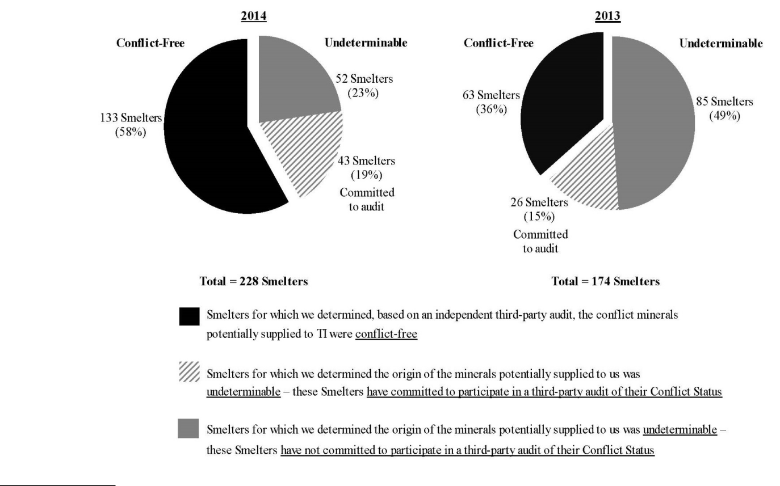

- “Integrated circuits” refers to finished semiconductor products that contain chips manufactured by or for TI and packaging subcomponents such as mold compound, bond wire and a lead frame. It excludes DLP® products and semiconductor modules, which also contain other electrical components such as capacitors and resistors.

2

Smelter Status – By CM
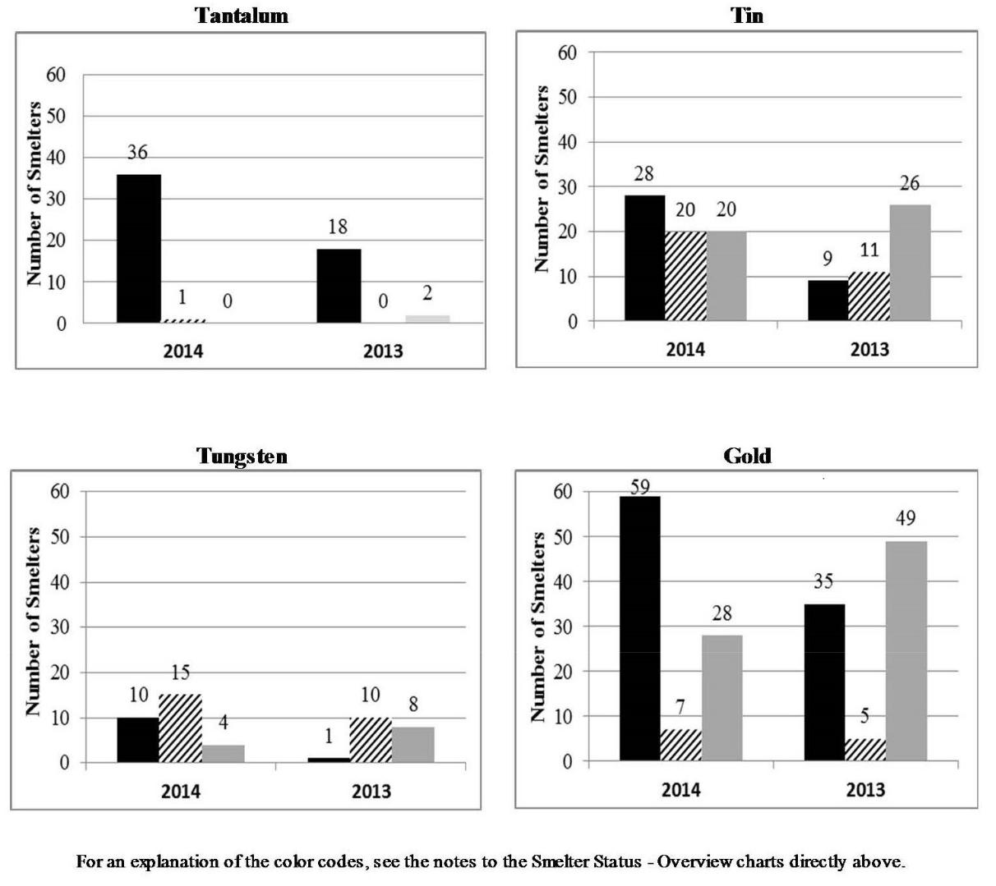

The potential Smelters that processed materials of undeterminable origin are identified in the Appendix hereto.

On the basis of our due diligence, we found with respect to each of our products that (1) the information we had gathered had failed to clarify the country of origin and Conflict Status of at least one of the CMs contained in the product and (2) no CMs were from a source that, to our knowledge, was directly or indirectly financing or benefiting armed conflict in a Covered Country.

Our products are in the following categories as described in our annual report on Form 10-K for the year ending December 31, 2014: Analog products (including High Volume Analog & Logic, Power Management, High Performance Analog and Silicon Valley Analog products); Embedded Processing products (including Processor, Microcontrollers and Connectivity products); and Other products (including DLP products, custom semiconductors known as application-specific integrated circuits and calculators). For further information about our products, please see the description of our products in Item 1 of the Form 10-K, which description is incorporated herein by reference.

Our efforts to determine the mine or location of origin of the CMs consisted of the due diligence measures described above.

3

Since the period covered by this Report, we have taken, or will take, the following steps to mitigate the risk that our CMs benefit armed groups in the Covered Countries, including to improve our due diligence:

- redistribute copies of our CM policy to Suppliers;

- emphasize to them our expectation that they respond fully and promptly to our information requests;

- instruct them to advise us if they determine that any person or entity in their supply chain is directly or indirectly financing or benefiting armed groups in the Covered Countries; and

- encourage them to direct all Smelters in their supply chains to participate in the CFSP or a similar third-party audit program.

This Conflict Minerals Report and our conflict minerals policy are available on our web site at www.ti.com/conflictminerals. We are not incorporating by reference the contents of our web site into this Conflict Minerals Report.

[Intentionally blank]

4

Appendix

Listed below are the 95 Smelters we have determined to be potentially in our supply chain for 2014 that have processed CMs of undeterminable origin. “Active” means the Smelter has committed to participate in a third-party audit of its Conflict Status. As explained above, the presence of a Smelter on the list does not mean that TI products necessarily contained CMs processed by that Smelter. The location information and “Active” status are as reported by the CFSP as of March 13, 2015.

 | Conflict
Smelter | Mineral | Location | Active
King-Tan Tantalum Industry Ltd. | Tantalum | CHINA | √
China Tin Group Co., Ltd. | Tin | CHINA | √
Cooper Santa | Tin | BRAZIL | √
CV Gita Pesona | Tin | INDONESIA | √
CV Nurjanah | Tin | INDONESIA | √
CV Serumpun Sebalai | Tin | INDONESIA | √
Fenix Metals | Tin | POLAND | √
Jiangxi Ketai Advanced Material Co., Ltd. | Tin | CHINA | √
O.M. Manufacturing (Thailand) Co., Ltd. | Tin | THAILAND | √
PT Artha Cipta Langgeng | Tin | INDONESIA | √
PT Belitung Industri Sejahtera | Tin | INDONESIA | √
PT BilliTin Makmur Lestari | Tin | INDONESIA | √
PT JusTindo | Tin | INDONESIA | √
PT Karimun Mining | Tin | INDONESIA | √
PT Mitra Stania Prima | Tin | INDONESIA | √
PT Panca Mega Persada | Tin | INDONESIA | √
PT Sumber Jaya Indah | Tin | INDONESIA | √
PT Tinindo Inter Nusa | Tin | INDONESIA | √
Rui Da Hung | Tin | TAIWAN | √
Soft Metais, Ltda. | Tin | BRAZIL | √
Yunnan Chengfeng Non-ferrous Metals Co., Ltd. | Tin | CHINA | √
CNMC (Guangxi) PGMA Co. Ltd. | Tin | CHINA
CV Makmur Jaya | Tin | INDONESIA
Feinhütte Halsbrücke GmbH | Tin | GERMANY
 | 5

Gejiu Kai Meng Industry and Trade LLC | Tin | CHINA
Gejiu Zi-Li | Tin | CHINA
Huichang Jinshunda Tin Co. Ltd. | Tin | CHINA
Linwu Xianggui Smelter Co. | Tin | CHINA
Metallic Resources Inc. | Tin | UNITED STATES
Novosibirsk Integrated Tin Works | Tin | RUSSIAN FEDERATION
PT Alam Lestari Kencana | Tin | INDONESIA
PT Babel Surya Alam Lestari | Tin | INDONESIA
PT Bangka Kudai Tin | Tin | INDONESIA
PT Bangka Timah Utama Sejahtera | Tin | INDONESIA
PT Fang Di MulTindo | Tin | INDONESIA
PT HP Metals Indonesia | Tin | INDONESIA
PT Koba Tin | Tin | INDONESIA
PT Pelat Timah Nusantara Tbk | Tin | INDONESIA
PT Seirama Tin Investment | Tin | INDONESIA
PT Tommy Utama | Tin | INDONESIA
PT Yinchendo Mining Industry | Tin | INDONESIA
A.L.M.T. Tungsten Corp. | Tungsten | JAPAN | √
Chenzhou Diamond Tungsten Products Co., Ltd. | Tungsten | CHINA | √
Chongyi Zhangyuan Tungsten Co., Ltd. | Tungsten | CHINA | √
Dayu Weiliang Tungsten Co., Ltd. | Tungsten | CHINA | √
Fujian Jinxin Tungsten Co., Ltd. | Tungsten | CHINA | √
Ganzhou Non-ferrous Metals Smelting Co., Ltd. | Tungsten | CHINA | √
Guangdong Xianglu Tungsten Co., Ltd. | Tungsten | CHINA | √
H.C. Starck GmbH | Tungsten | GERMANY | √
H.C. Starck Smelting GmbH & Co. KG | Tungsten | GERMANY | √
Hunan Chenzhou Mining Group Co., Ltd. | Tungsten | CHINA | √
Jiangxi Xinsheng Tungsten Industry Co., Ltd. | Tungsten | CHINA | √
Kennametal Fallon | Tungsten | UNITED STATES | √
 | 6

Kennametal Huntsville | Tungsten | UNITED STATES | √
Wolfram Bergbau und Hütten AG | Tungsten | AUSTRIA | √
Xinhai Rendan Shaoguan Tungsten Co., Ltd. | Tungsten | CHINA | √
Jiangxi Minmetals Gao'an Non-ferrous Metals Co., Ltd. | Tungsten | CHINA
Jiangxi Richsea New Materials Co., Ltd. | Tungsten | CHINA
Tejing (Vietnam) Tungsten Co., Ltd. | Tungsten | VIETNAM
Wolfram Company CJSC | Tungsten | RUSSIAN FEDERATION
Aida Chemical Industries Co. Ltd. | Gold | JAPAN | √
Asaka Riken Co. Ltd. | Gold | JAPAN | √
Cendres + Métaux SA | Gold | SWITZERLAND | √
Sabin Metal Corp. | Gold | UNITED STATES | √
SOE Shyolkovsky Factory of Secondary Precious Metals | Gold | RUSSIAN FEDERATION | √
Yamamoto Precious Metal Co., Ltd. | Gold | JAPAN | √
Yokohama Metal Co. Ltd. | Gold | JAPAN | √
Almalyk Mining and Metallurgical Complex (AMMC) | Gold | UZBEKISTAN
Bangko Sentral ng Pilipinas (Central Bank of the Philippines) | Gold | PHILIPPINES
Caridad | Gold | MEXICO
Chugai Mining | Gold | JAPAN
Daejin Indus. Co. Ltd. | Gold | KOREA, REPUBLIC OF
Do Sung Corporation | Gold | KOREA, REPUBLIC OF
Doduco | Gold | GERMANY
Faggi Enrico Spa | Gold | ITALY
FSE Novosibirsk Refinery | Gold | RUSSIAN FEDERATION
Guangdong Jinding Gold Limited | Gold | CHINA
Hwasung CJ Co. Ltd. | Gold | KOREA, REPUBLIC OF
Inner Mongolia Qiankun Gold and Silver Refinery Share Company | Gold | CHINA
Limited
Jiangxi Copper Company Limited | Gold | CHINA
JSC Uralelectromed | Gold | RUSSIAN FEDERATION
 | 7

Korea Metal Co. Ltd. | Gold | KOREA, REPUBLIC OF
Kyrgyzaltyn JSC | Gold | KYRGYZSTAN
Lingbao Jinyuan Tonghui Refinery Co. Ltd. | Gold | CHINA
Moscow Special Alloys Processing Plant | Gold | RUSSIAN FEDERATION
Navoi Mining and Metallurgical Combinat | Gold | UZBEKISTAN
OJSC Kolyma Refinery | Gold | RUSSIAN FEDERATION
Prioksky Plant of Non-Ferrous Metals | Gold | RUSSIAN FEDERATION
Samwon Metals Corp. | Gold | KOREA, REPUBLIC OF
So Accurate Group, Inc. | Gold | UNITED STATES
The Great Wall Gold and Silver Refinery of China | Gold | CHINA
Tongling Nonferrous Metals Group Co., Ltd. | Gold | CHINA
Torecom | Gold | KOREA, REPUBLIC OF
Zhongyuan Gold Smelter of Zhongjin Gold Corporation | Gold | CHINA
Zijin Mining Group Co. Ltd. | Gold | CHINA
 | 8

