FILED BY TEXAS INSTRUMENTS INCORPORATED
PURSUANT TO RULE 425 UNDER THE SECURITIES ACT OF 1933
AND DEEMED FILED PURSUANT TO RULE 14a-12 AND RULE 14d-2(b)
UNDER THE SECURITIES EXCHANGE ACT OF 1934
SUBJECT COMPANY: SILICON LABORATORIES INC.
COMMISSION FILE NO. 000-29823
On February 4, 2026, Texas Instruments Incorporated posted the following communications:

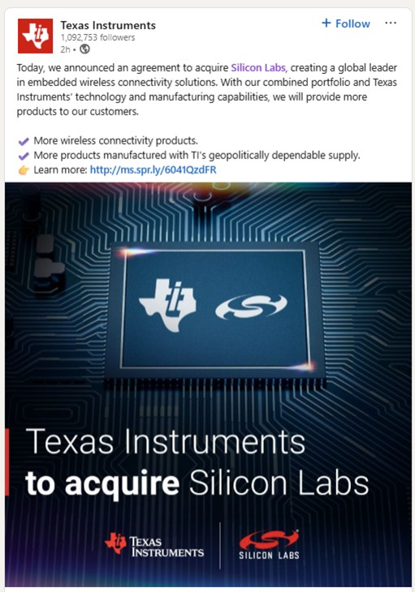

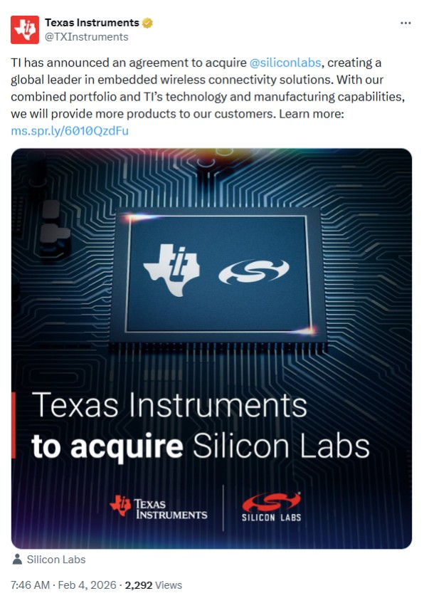

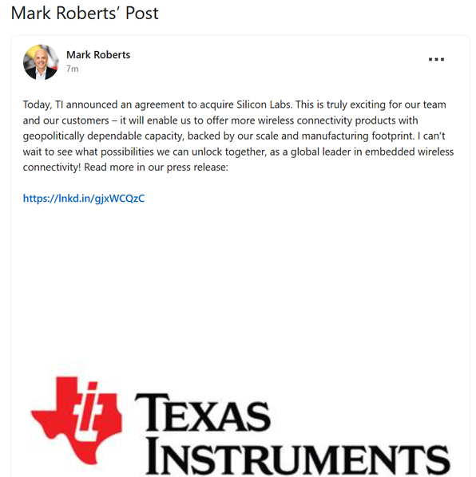

Additional information and where to find it
In connection with the proposed transaction, Silicon Labs plans to file a proxy statement with the Securities and Exchange Commission (“SEC”) with respect to a special meeting of stockholders for purposes of obtaining stockholder approval of the proposed transaction. STOCKHOLDERS OF SILICON LABS ARE URGED TO READ THE PROXY STATEMENT (INCLUDING ANY AMENDMENTS OR SUPPLEMENTS THERETO AND ANY DOCUMENTS INCORPORATED BY REFERENCE THEREIN) AND OTHER RELEVANT DOCUMENTS IN CONNECTION WITH THE PROPOSED TRANSACTION THAT SILICON LABS WILL FILE WITH THE SEC WHEN THEY BECOME AVAILABLE BECAUSE THEY WILL CONTAIN IMPORTANT INFORMATION ABOUT THE PROPOSED TRANSACTION AND THE PARTIES TO THE PROPOSED TRANSACTION. Stockholders and investors will be able to obtain free copies of the proxy statement and other relevant materials (when available) and other documents filed by Silicon Labs at the SEC’s website at www.sec.gov. Copies of the proxy statement (when available) and the filings that will be incorporated by reference therein may also be obtained, without charge, by contacting Silicon Labs’ Investor Relations at investor.relations@silabs.com or (512) 416-8500.
Participants in Solicitation
Texas Instruments, Silicon Labs and their respective directors and executive officers may be deemed, under SEC rules, to be participants in the solicitation of proxies in respect of the proposed transaction. Information regarding Texas Instruments’ directors and executive officers is available in (a) Texas Instruments’ Annual Report on Form 10-K for the fiscal year ended December 31, 2024, including under the headings “ITEM 10. Directors, executive officers and corporate governance,” “ITEM 11. Executive compensation,” “ITEM 12. Security ownership of certain beneficial owners and management and related stockholder matters” and “ITEM 13. Certain relationships and related transactions, and director independence,” which was filed with the SEC on February 14, 2025, and can be found at www.sec.gov; (b) Texas Instruments’ definitive proxy statement for its 2025 annual meeting of stockholders, which was filed with the SEC on March 5, 2025, under the headings “Election of directors,” “Executive compensation,” and “Security ownership of directors and management,” and can be found at www.sec.gov; and (c) subsequently filed Current Reports on Form 8-K and Quarterly Reports on Form 10-Q. To the extent holdings of Texas Instruments’ securities by its directors or executive officers have changed since the amounts set forth in Texas Instruments’ proxy statement for its 2025 annual meeting of stockholders, such changes have been or will be reflected on Forms 3, 4 and 5, filed with the SEC (which can be found at www.sec.gov). Copies of the documents filed with the SEC by Texas Instruments will be available free of charge through the website maintained by the SEC at www.sec.gov and Texas Instruments’ website at https://investor.ti.com/. Information regarding Silicon Labs’ directors and executive officers is available in (a) Silicon Labs’ Annual Report on Form 10-K for the fiscal year ended December 28, 2024, including under the headings “Item 10. Directors, Executive Officers and Corporate Governance,” “Item 11. Executive Compensation,” “Item 12. Security Ownership of Certain Beneficial Owners and Management and Related Stockholder Matters” and “Item 13. Certain Relationships, Related Transactions, and

Director Independence,” which was filed with the SEC on February 4, 2025, and can be found at www.sec.gov; (b) Silicon Labs’ definitive proxy statement for its 2025 annual meeting of stockholders, which was filed with the SEC on March 12, 2025, under the headings “Proposal One: Election of Directors,” “Ownership of Securities,” “Executive Officers,” and “Compensation Discussion and Analysis,” and can be found at www.sec.gov; and (c) subsequently filed Current Reports on Form 8-K and Quarterly Reports on Form 10-Q. To the extent holdings of Silicon Labs’ securities by its directors or executive officers have changed since the amounts set forth in Silicon Labs’ proxy statement for its 2025 annual meeting of stockholders, such changes have been or will be reflected on Forms 3, 4 and 5, filed with the SEC (which can be found at www.sec.gov). Other information regarding the participants in the solicitation and a description of their direct and indirect interests, by security holdings or otherwise, will be set forth in Silicon Labs’ definitive proxy statement and other relevant materials to be filed with the SEC regarding the proposed transaction when such materials become available. Investors and stockholders should read the proxy statement carefully when it becomes available before making any voting or investment decisions. Copies of these documents may be obtained, free of charge, from the sources indicated above.
Non-GAAP Financial Measures
This presentation includes certain non-GAAP financial measures, including free cash flow and free cash flow per share, which are not prepared in accordance with generally accepted accounting principles in the United States (“GAAP”) and may be different from non-GAAP financial measures used by other companies. These non-GAAP financial measures are presented to provide investors with additional information and should not be considered in isolation or as a substitute for financial measures calculated in accordance with GAAP.
No Offer or Solicitation
This communication is for informational purposes only and does not constitute an offer to sell or the solicitation of an offer to buy any securities or a solicitation of any vote or approval, nor shall there be any sale of securities in any jurisdiction in which such offer, solicitation or sale would be unlawful prior to registration or qualification under the securities laws of any such jurisdiction. No offer of securities shall be made except by means of a prospectus meeting the requirements of Section 10 of the Securities Act of 1933, as amended, and otherwise in accordance with applicable law.
Cautionary Statement Regarding Forward-Looking Statements
This communication contains “forward-looking statements” within the meaning of of Section 27A of the Securities Act of 1933, as amended, and Rule 175 promulgated thereunder, and Section 21E of the Securities Exchange Act of 1934, as amended, and Rule 3b-6 promulgated thereunder. Such statements include statements concerning anticipated future events and expectations that are not historical facts. Any statements about Texas Instruments’ (“Texas Instruments”) or Silicon Labs’ (“Silicon Labs”) plans, objectives, expectations, strategies, beliefs, or future performance or events constitute

forward-looking statements. Forward-looking statements are typically identified by words such as “believe,” “expect,” “anticipate,” “intend,” “target,” “estimate,” “continue,” “positions,” “plan,” “predict,” “project,” “forecast,” “guidance,” “goal,” “objective,” “prospects,” “possible” or “potential,” by future conditional verbs such as “assume,” “will,” “would,” “should,” “could” or “may,” or by variations of such words or by similar expressions or the negative thereof. Such forward-looking statements include but are not limited to statements about the benefits of the proposed transaction, including future financial and operating results, Texas Instruments’ or Silicon Labs’ plans, objectives, expectations and intentions, the expected timing of completion of the proposed transaction and other statements that are not historical facts. Actual results may vary materially from those expressed or implied by forward-looking statements based on a number of factors, including, without limitation: (1) risks related to the consummation of the proposed transaction, including the risks that (a) the proposed transaction may not be consummated within the anticipated time period, or at all, (b) the parties may fail to obtain Silicon Labs stockholder approval of the merger agreement, (c) the parties may fail to secure the termination or expiration of any waiting period applicable under the Hart-Scott-Rodino Antitrust Improvements Act of 1976, as amended, or obtain other required governmental and regulatory approvals, and (d) other conditions to the consummation of the proposed transaction under the merger agreement may not be satisfied; (2) the effects that any termination of the merger agreement may have on Texas Instruments or Silicon Labs or their respective businesses, including the risks that Texas Instruments’ or Silicon Labs’ stock price may decline significantly if the proposed transaction is not completed; (3) the effects that the announcement or pendency of the proposed transaction may have on Texas Instruments or Silicon Labs and their respective businesses, including the risks that as a result (a) Texas Instruments’ or Silicon Labs’ business, operating results or stock price may suffer, (b) Texas Instruments’ or Silicon Labs’ current plans and operations may be disrupted, (c) Texas Instruments’ or Silicon Labs’ ability to retain or recruit key employees may be adversely affected, (d) Texas Instruments’ or Silicon Labs’ business relationships (including, customers and suppliers) may be adversely affected, or (e) Texas Instruments’ or Silicon Labs’ management’s or employees’ attention may be diverted from other important matters; (4) the effect of limitations that the merger agreement places on Silicon Labs’ ability to operate its business, return capital to stockholders or engage in alternative transactions; (5) the nature, cost and outcome of pending and future litigation and other legal proceedings, including any such proceedings related to the proposed transaction and instituted against Silicon Labs and others; (6) the risk that the proposed transaction and related transactions may involve unexpected costs, liabilities or delays; (7) other economic, business, competitive, legal, regulatory, and/or tax factors, including the impact of the current global memory chip shortage; and (8) other factors described in the reports of (a) Texas Instruments filed with the SEC, including but not limited to the risks described in Texas Instruments’ Annual Report on Form 10-K for its fiscal year ended December 31, 2024, which was filed with the SEC on February 14, 2025, and Texas Instruments’ Quarterly Reports on Form 10-Q, and that are otherwise described or updated from time to time in other filings with the SEC and (b) Silicon Labs filed with the SEC, including but not limited to the risks described in Silicon Labs’ Annual Report on Form

10-K for its fiscal year ended December 28, 2024, which was filed with the SEC on February 4, 2025, and Silicon Labs’ Quarterly Reports on Form 10-Q, and that are otherwise described or updated from time to time in other filings with the SEC. All forward-looking statements attributable to Texas Instruments or Silicon Labs, or persons acting on Texas Instruments’ or Silicon Labs’ behalf, are expressly qualified in their entirety by this cautionary statement. Further, each of Texas Instruments and Silicon Labs disclaims any obligation to update the information in this communication or to announce publicly the results of any revisions to any of the forward-looking statements to reflect future events or developments, except as otherwise required by law. Readers are cautioned not to place undue reliance on these forward-looking statements that speak only as of the date hereof.

